# Air Conditioning Delete for 1977 Camaro LT

This tutorial provides an overview for individuals removing the stock air-conditioning system in their 2nd generation GM F-Body cars.

## Parts Required

* [ ] AC Delete Cover (I did the Classic Industries 70-81 ABS AC Delete Cover - #14963 - https://www.classicindustries.com/product/all-years/chevrolet/camaro/parts/14963.html : $139.99)
  + This doesn't fit all that well on my firewall, I had to do some work to shoehorn it in. Specifically, pounding in the raised part of the firewall so that the fan would clear.
* [ ] Blower Motor Cage for Cars without AC (Classic Industries - #19953 - https://www.classicindustries.com/product/all-years/chevrolet/camaro/parts/19953.html : $19.99)
* [ ] Blower Motor Resistor (I got Dorman 973-430 Blower Motor Resistor kit - https://www.amazon.com/gp/product/B00FOOUVTW/ref=ppx_yo_dt_b_asin_title_o04_s00?ie=UTF8&psc=1 : $11.04)
* [ ] Blower Fan High relay (I got Four Seasons 35767 Relay - https://www.amazon.com/gp/product/B000C2QN9S/ref=ppx_yo_dt_b_asin_title_o03_s00?ie=UTF8&psc=1 : $12.09)
* [ ] Wire loom wrap

## Tools Required (as I recall)

* [ ] Sockets (not deep) [1/4, 3/8, 5/16]
* [ ] Knife (for cutting water hoses)
* [ ] Bucket (for collecting coolant)
* [ ] End wrenches matching sockets
* [ ] Wiring pliers
* [ ] Electrical testing indicator light
* [ ] Drill with 1 3/4" bit and 1" bit (although, could have gone just a bit smaller on the 1")

## Tear Down

1. Disconnect current electrical terminals to resistor, relay, and all corresponding connectors.

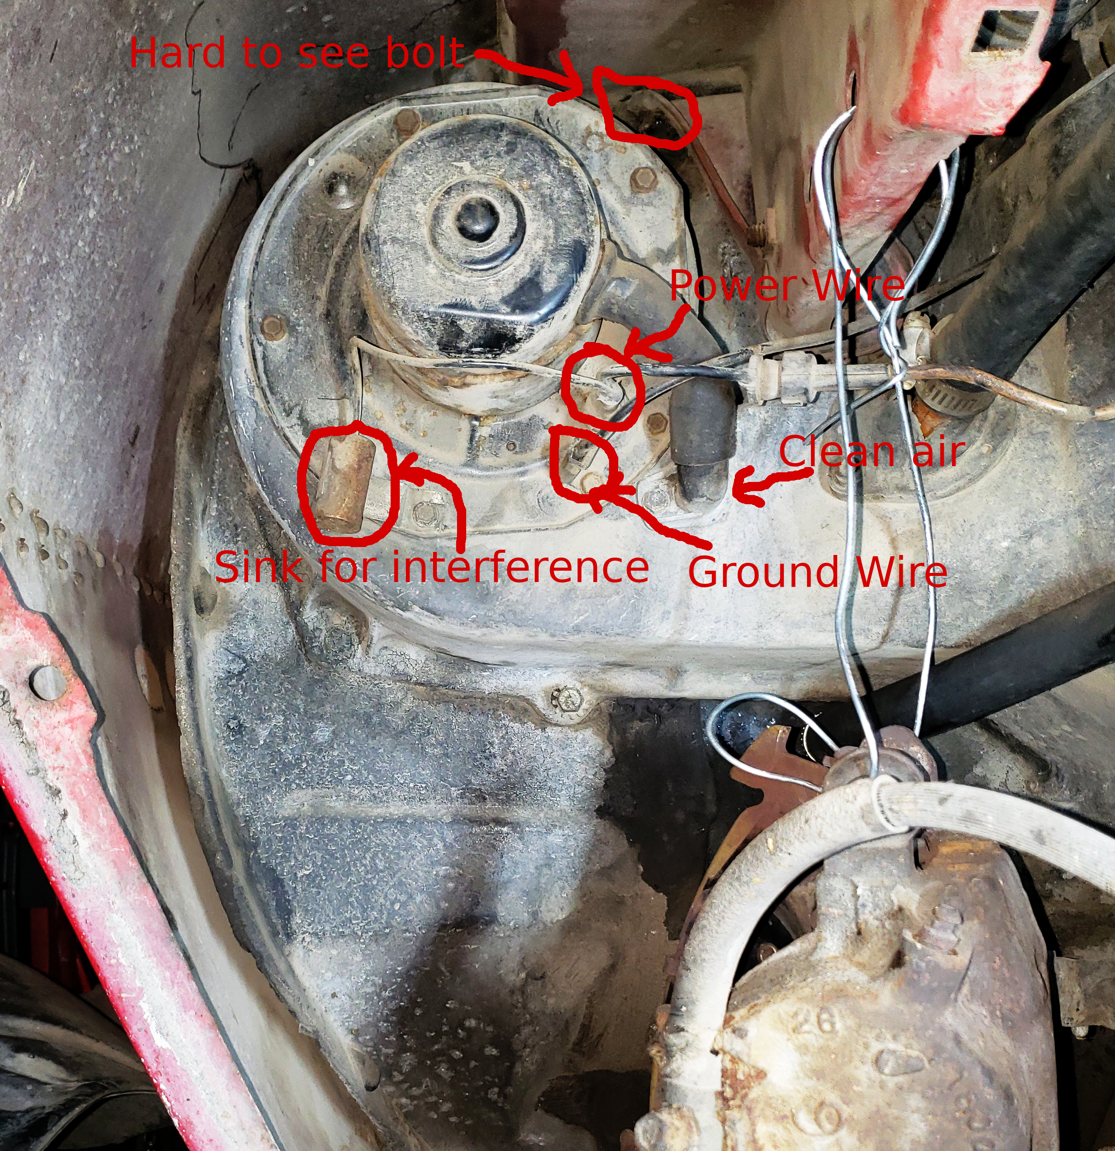

Original installation layout from wheelwell (with wheelwell removed)

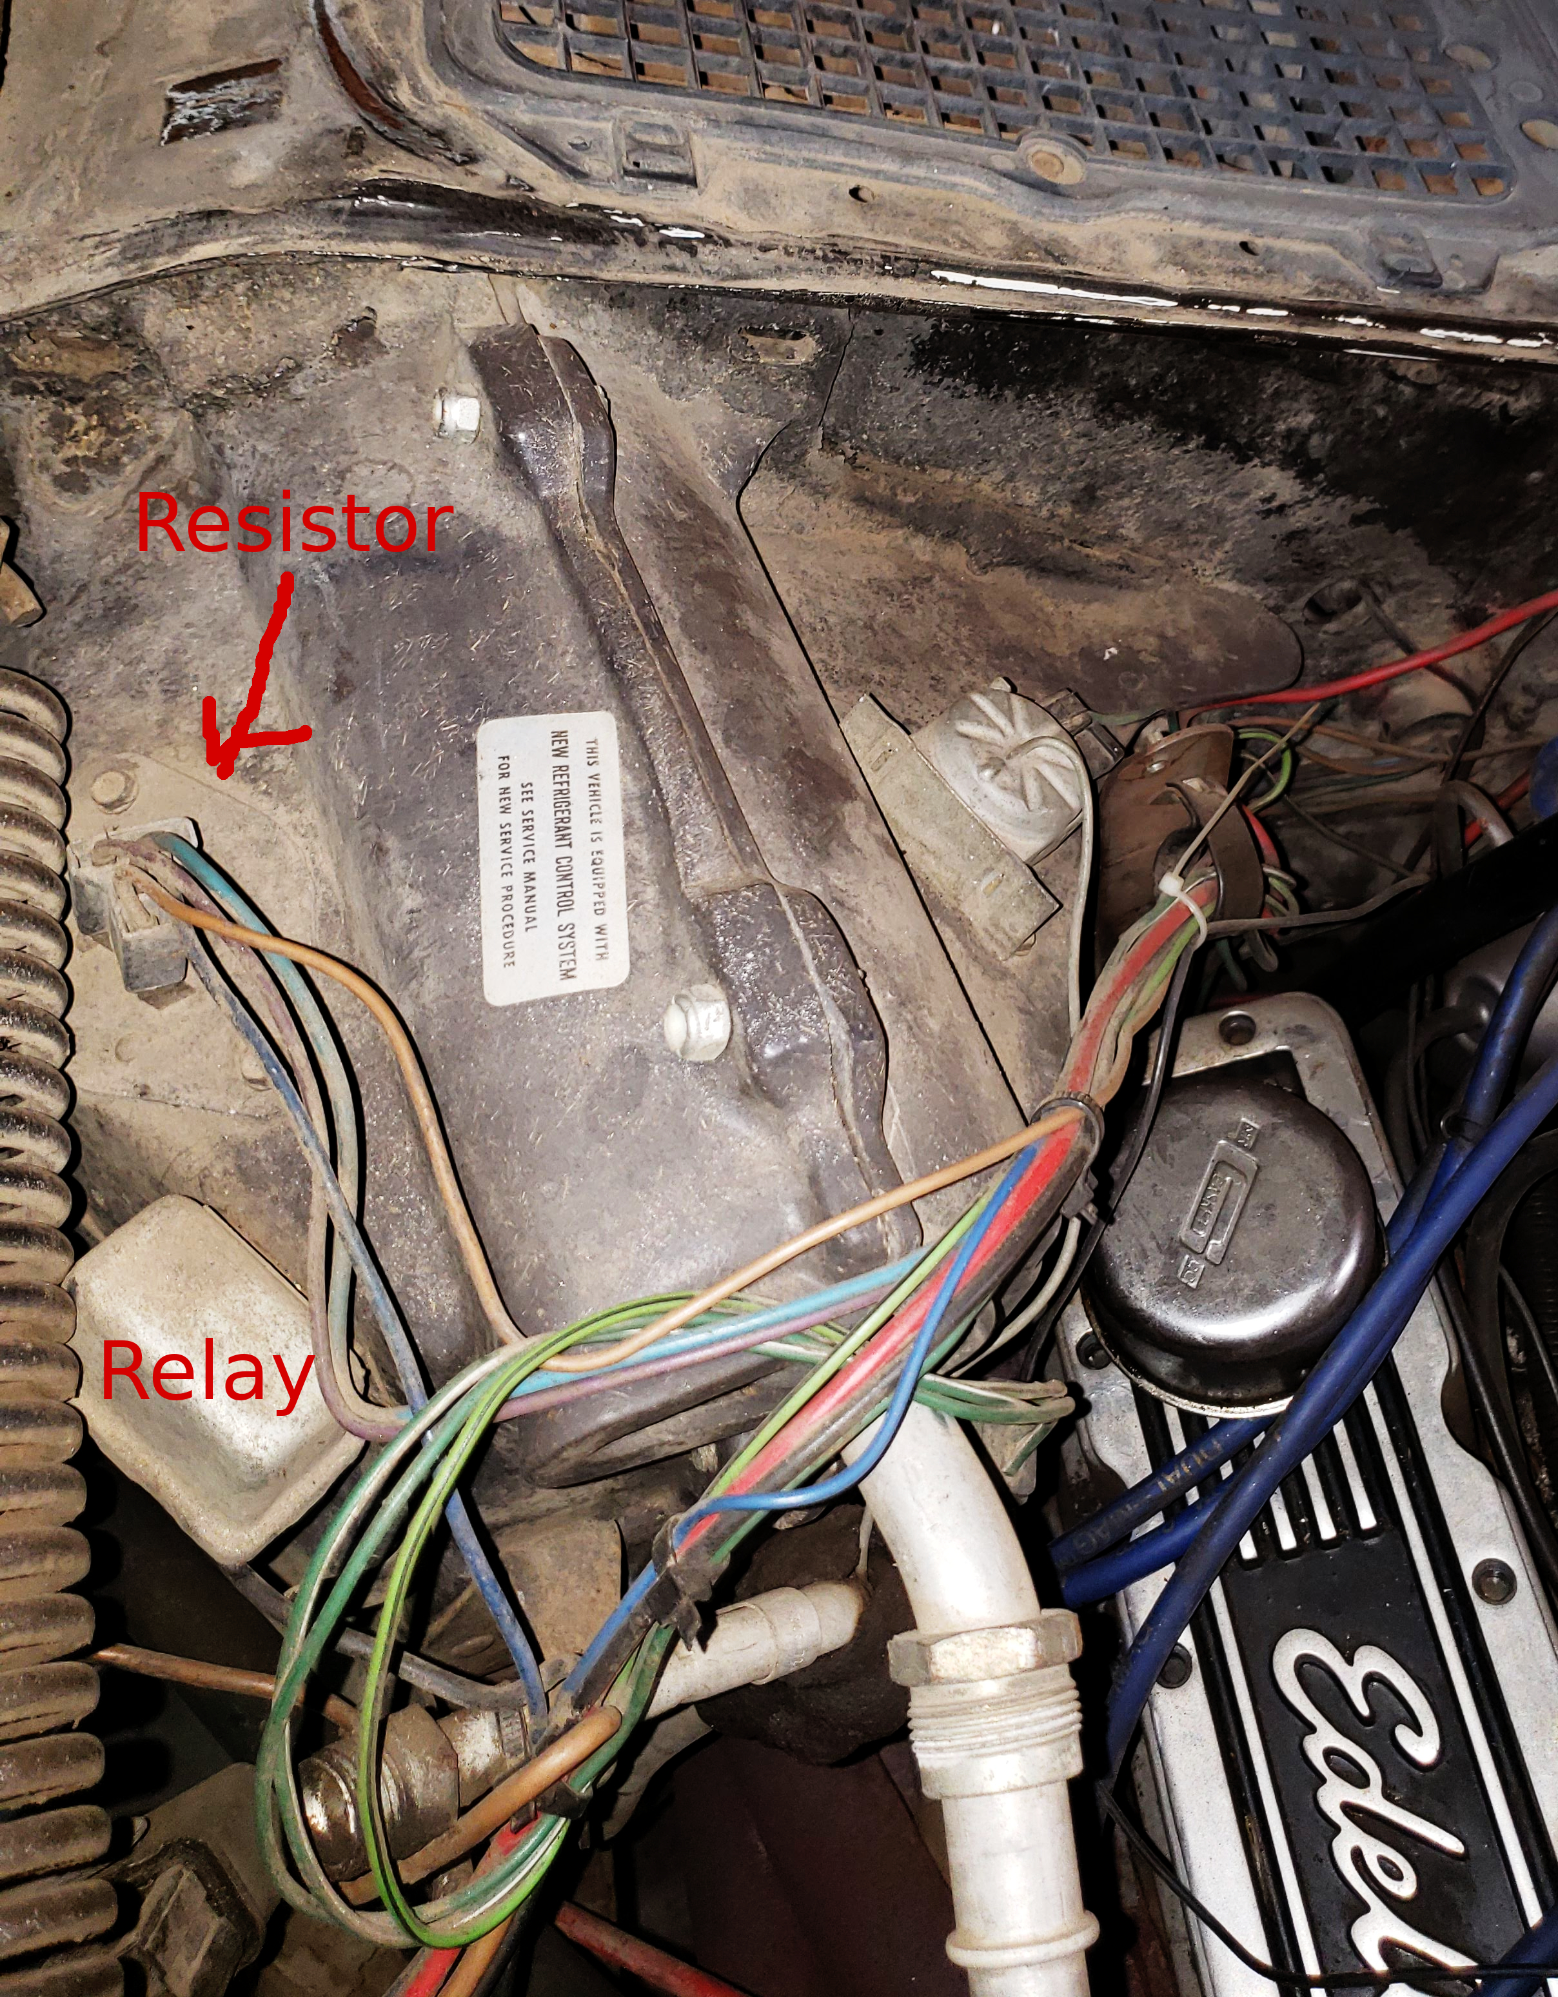

Original installation layout from above

1. Disconnect and mark both water lines to heater (mark upper and lower).
   * These were difficult to remove and should be cut from the heater core to avoid damaging the sauter of the piping to the core.
2. Remove heater fan.
   * Electrical connections (ground and power) and the interference sink (big metal cylinder).
   * Clean air hose should be unscrewed from current AC suitcase.
   * Small bolts around fan.
3. Remove bolts holding suitcase together (it has to be removed in 2 parts to fit).
   * 2xTop, 2xSide, 2xBottom (these are nearly impossible to access on the bottom with headers installed).
   * I ended up disconnecting top and side and then breaking bottom.
4. Remove bolts holding cover in place.
   * One at the bottom, near the headers is nearly unreachable. With a lot of patience, used a 3/8 end wrench from underneath.
   * One in top left of the box, above the heater fan (to the top right) is hard to see.

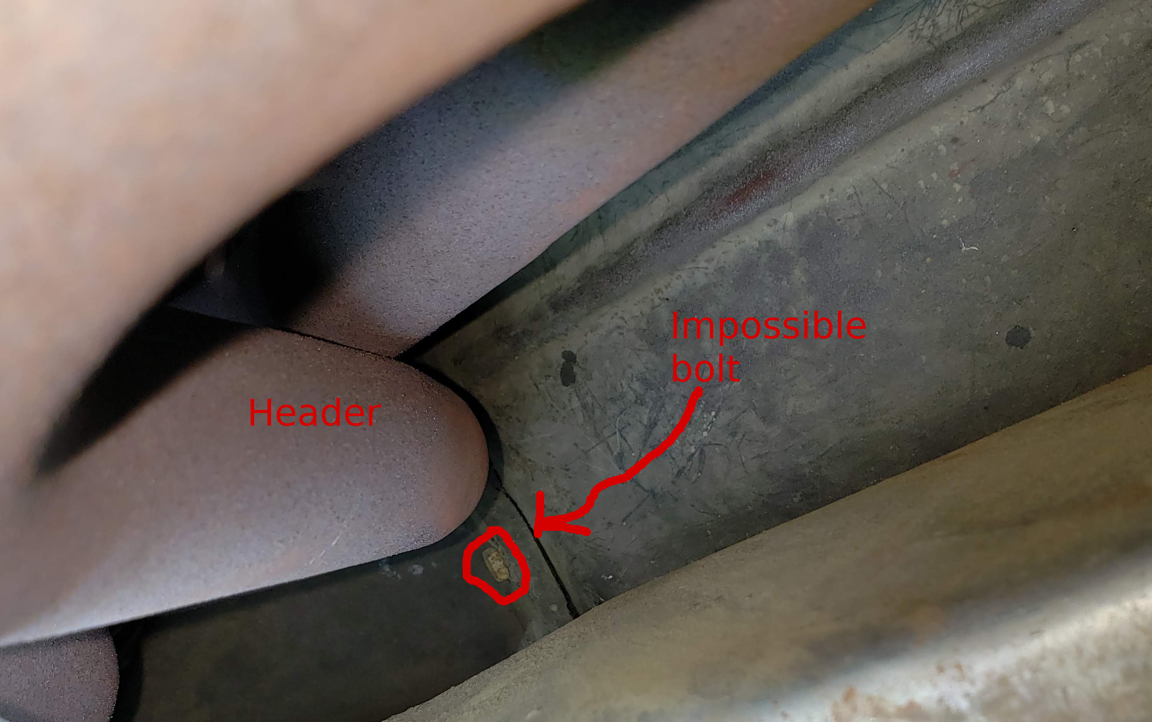

Picture showing "impossible bolt" from middle of car, with header in upper right

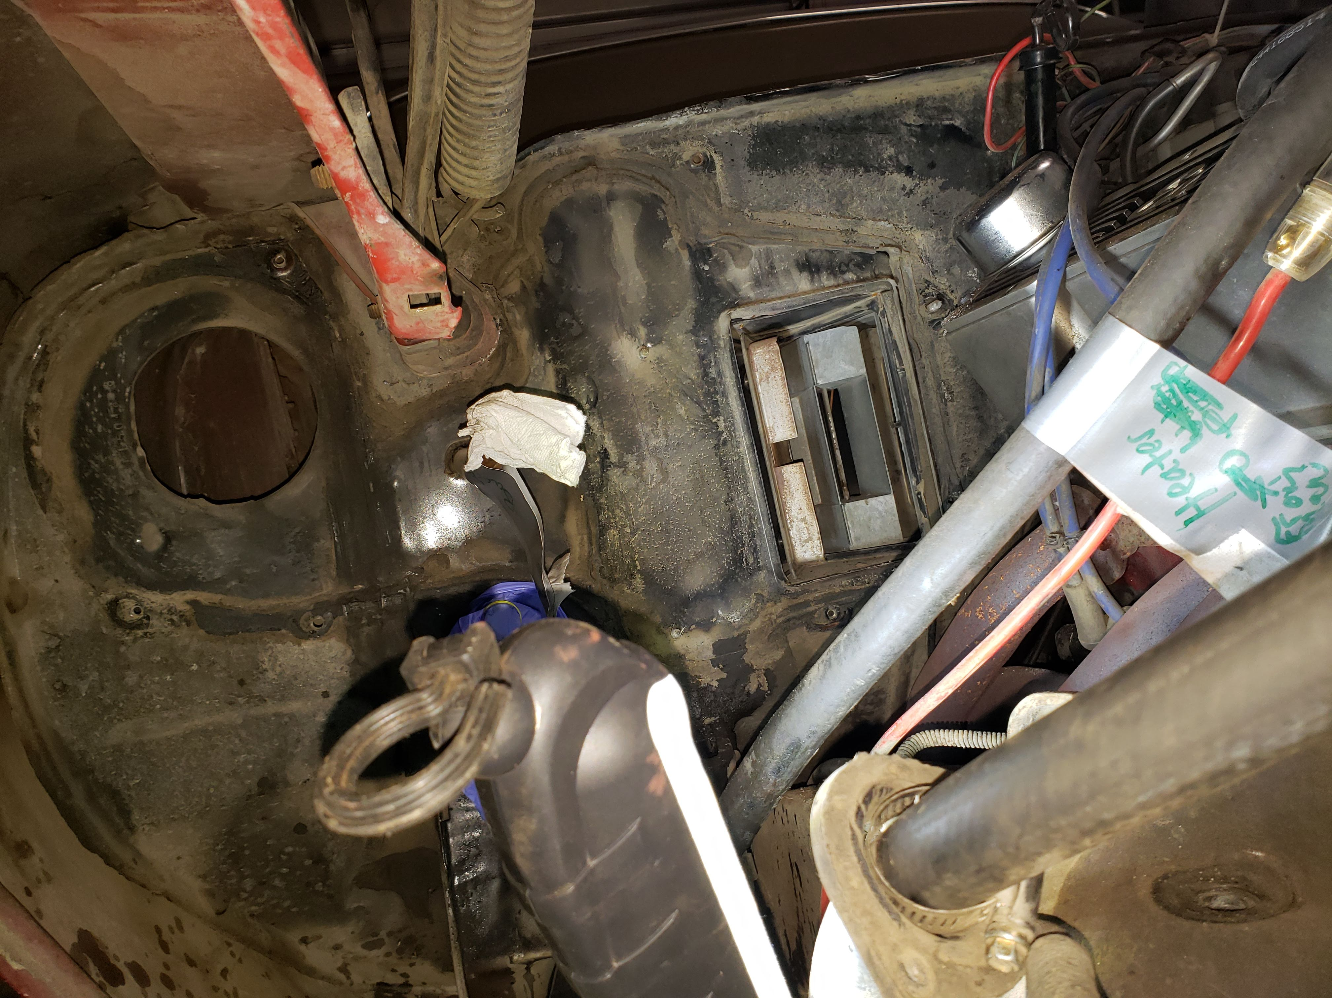

Picture showing firewall without AC suitcase, pre-cleanup

## Rebuild and Reinstall

1. Test Wires and cap unnecessary wires, see table 1.
   * I capped off the green wire, and was already using the tan (power) wire out of the firewall for the choke. I split that off to also run the cowl switch.
   * I left the yellow (low) on the new resistor disconnected to avoid the constant power state. This would have been the green wire.
   * Remember to connect ground to ground wire that will connect to blower motor.

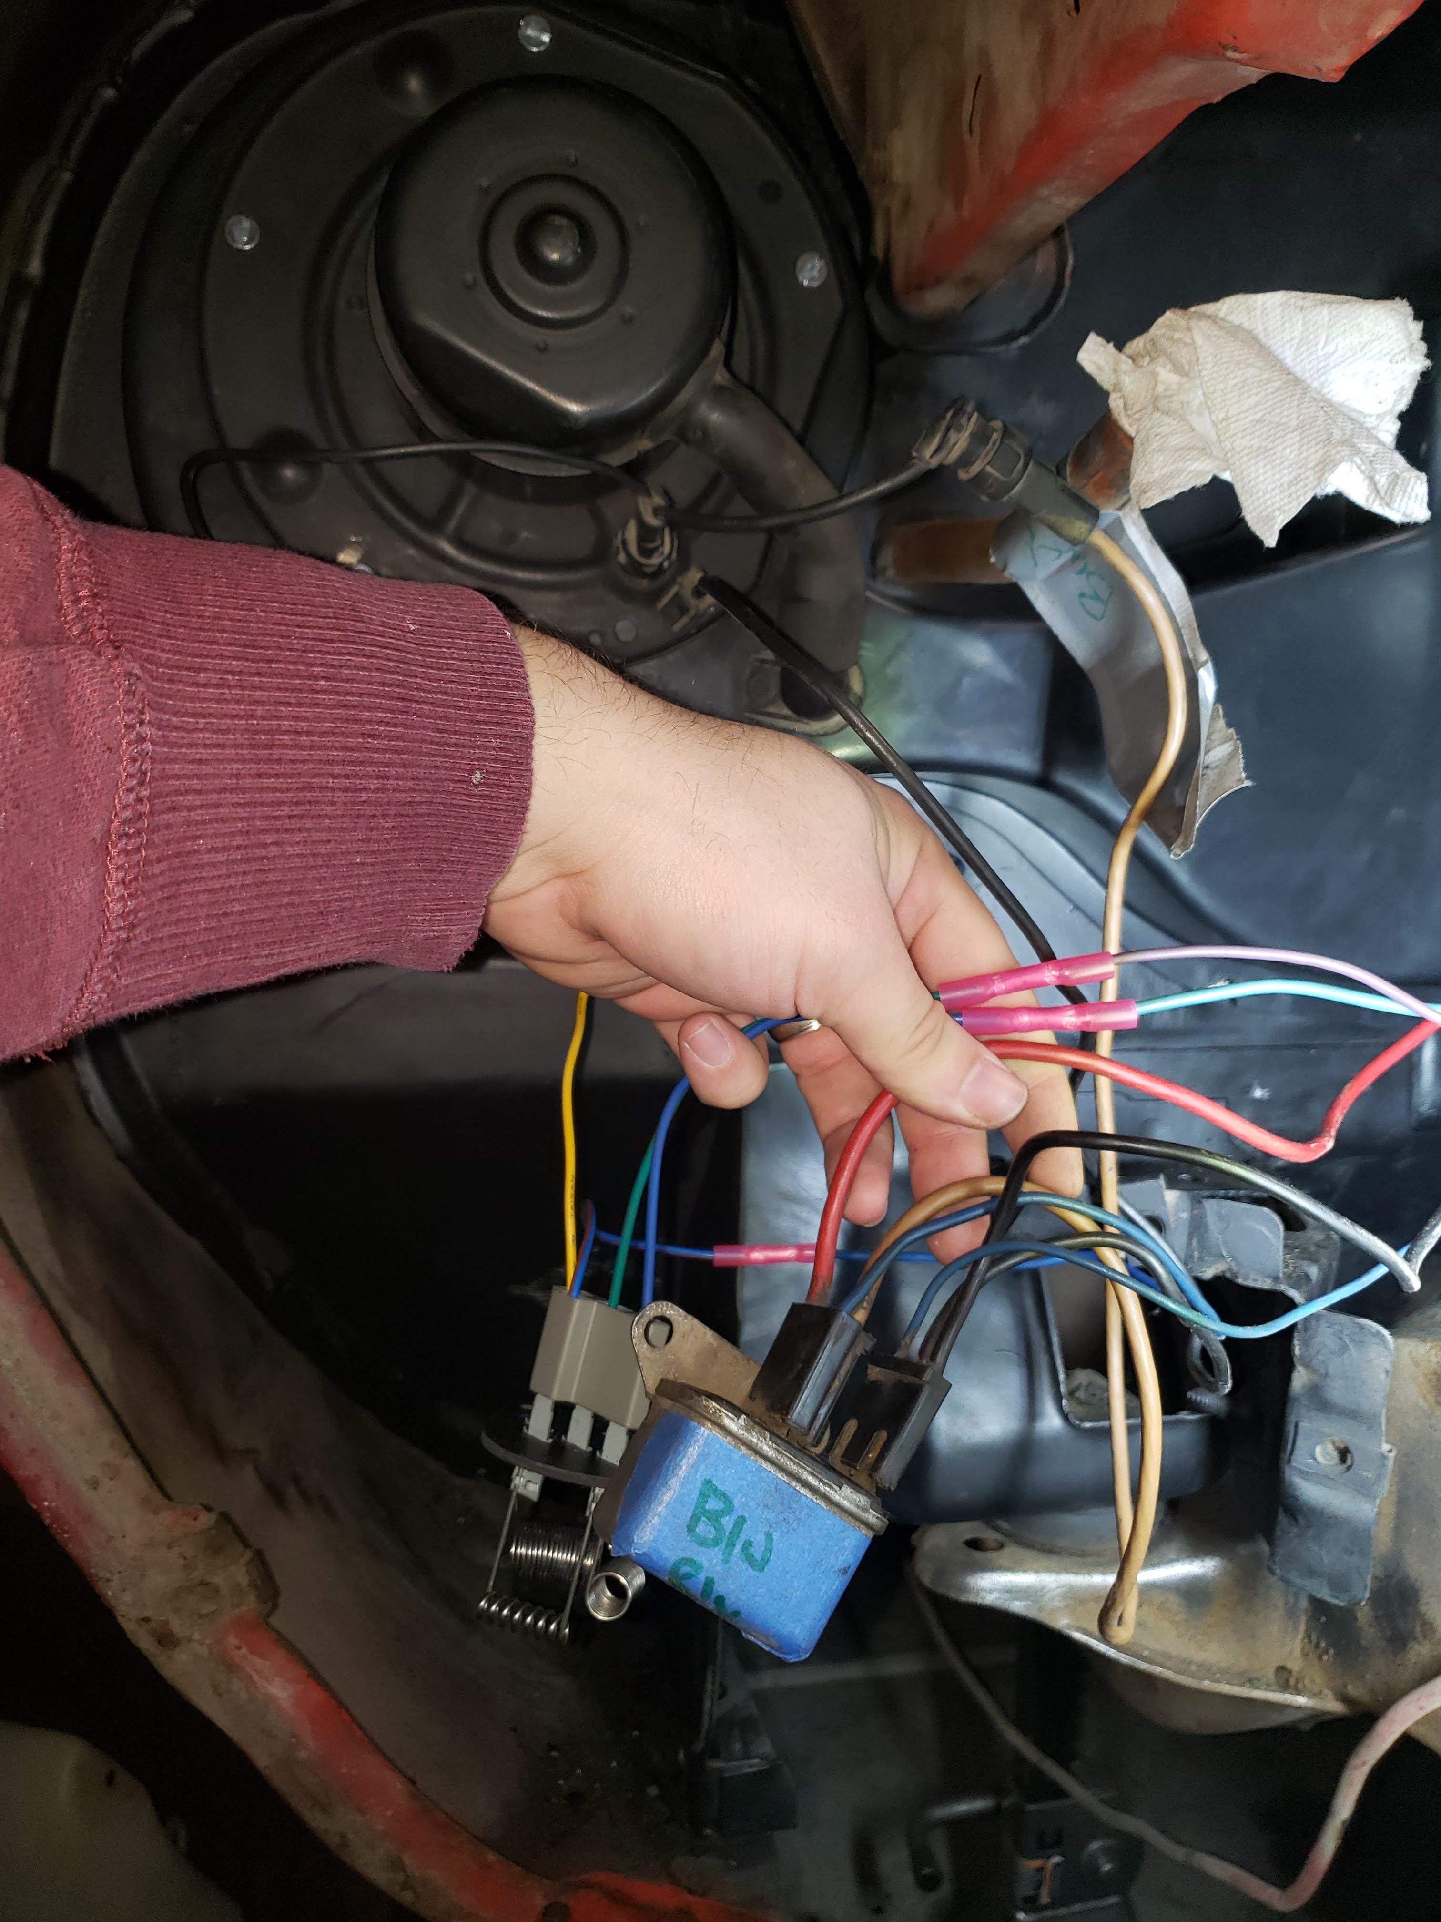

Wiring during testing, after installing new resistor

1. Install resistor in cover.
   * Drill 1 3/4" hole.
   * Drill 1" hole after marking location for fresh air into blower fan (a rubber hose).

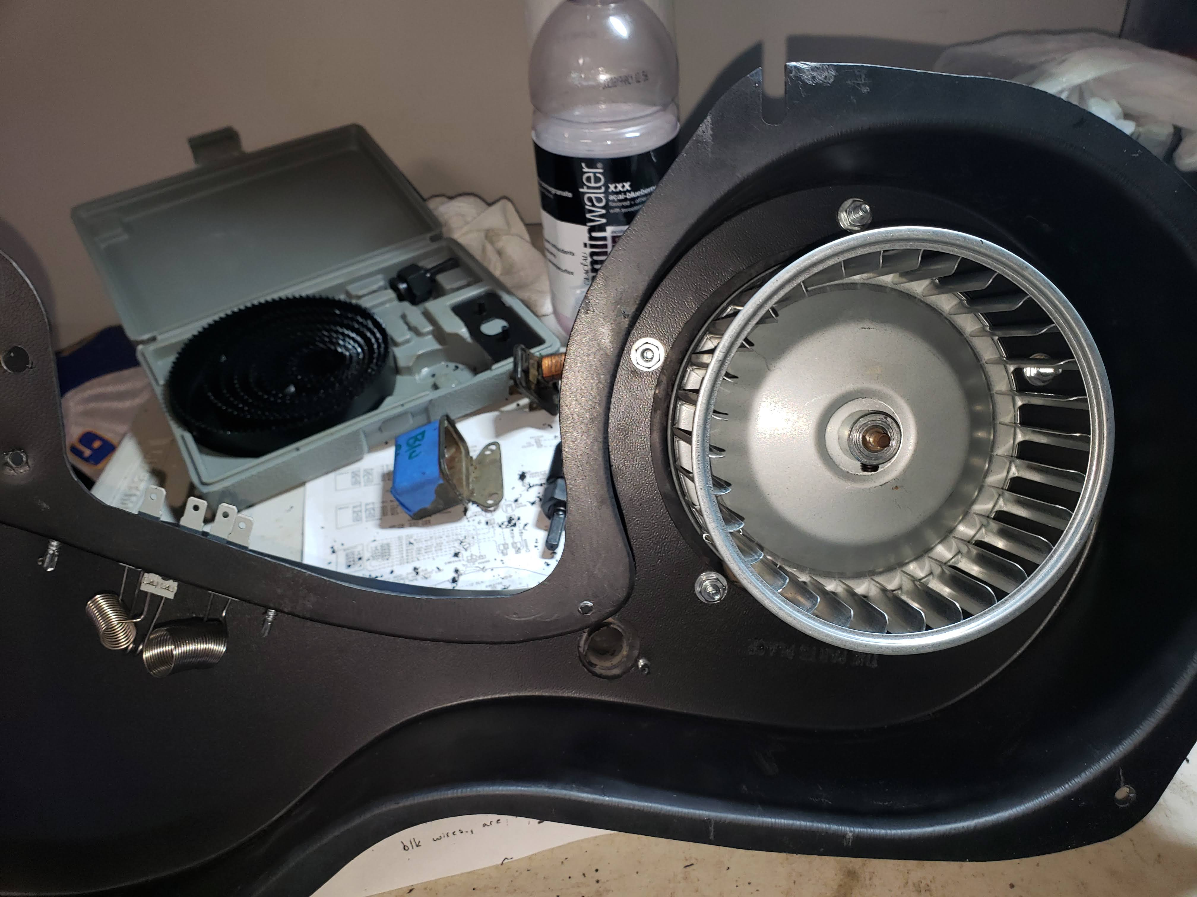

Back side of delete box, with resistor installed and the fresh air into blower fan installed

1. Install blower motor in box.
   * I got new bolts because I felt like the self-tapping screws would not be adequate in the non-metal frame of the box.
2. Mock up and check clearances
   * Had to flatten the hole in the firewall where the fan goes (clipped the lip inward and then hammered pieces in)
   * Added self-tapping holes and cut out pre-drilled holes in the box that didn't line up perfectly. The studs coming out of the firewall mostly did not align or could not hold nuts.
     + Top right above the blower fan had a very large washer on it, and then I started it before putting the box on. That way I could just slide the delete box into place (it has a groove not a hole).

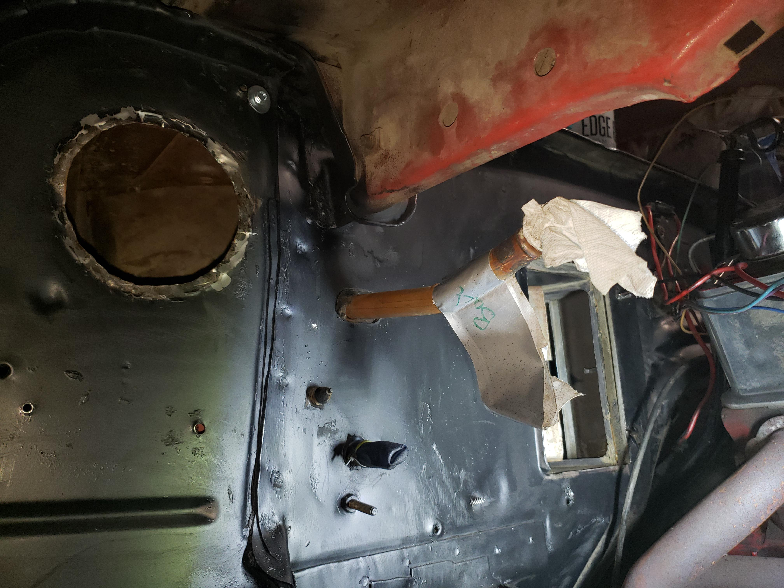

Picture showing firewall without AC suitcase, prepped for installation

1. Put a pretty hefty bead of silicone around lip of Delete Box and install.

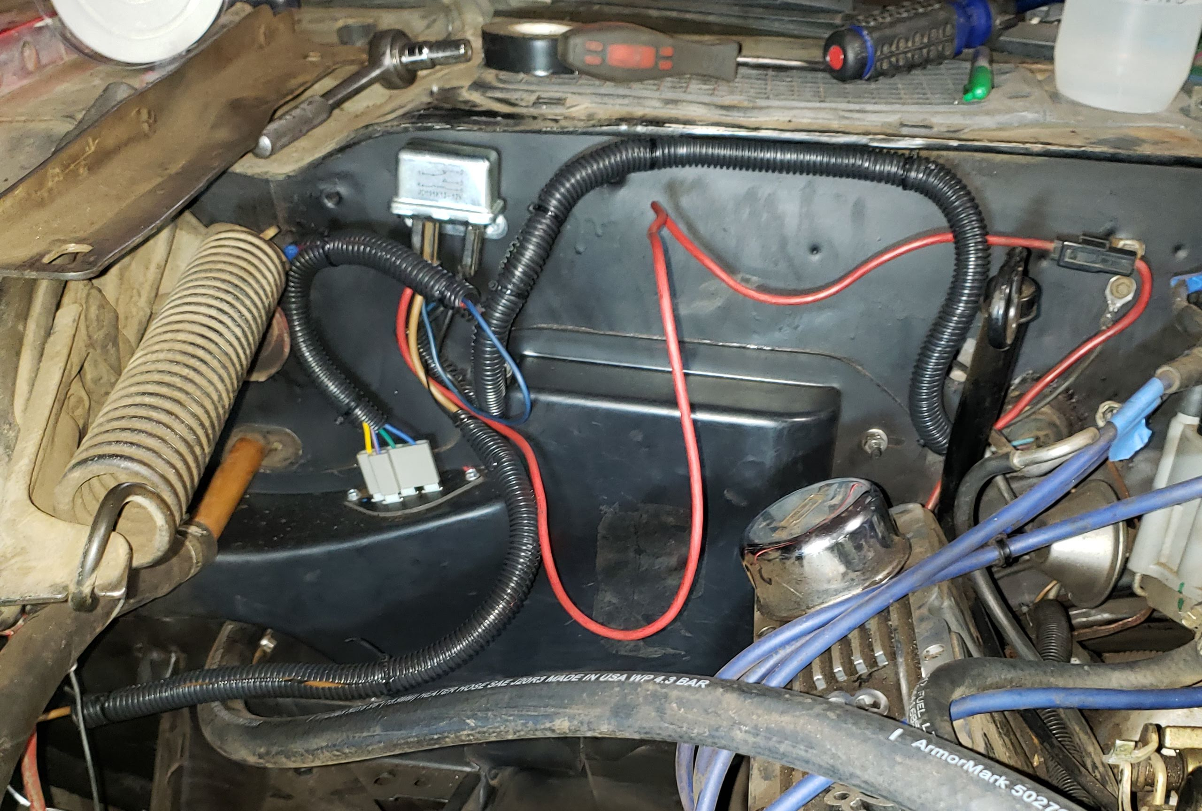

After final installation with wires in the wrapper, but not yet pinned to firewall

Table 1 - Wiring Diagram | Path | Purpose | |-----------------------------------|-----------------------| | Ign -> Tan -> AC Compressor | Switches on low fan when AC is on (not needed) | | Ign -> Green -> Resistor-Low | Low fan switchh | | Ign -> Purple -> Resistor-Medium | Low-Med fan switch | | Ign -> Light Blue -> Resistor-High| Med-High fan switch | | Ign -> Blue - Relay | High fan switch (bypasses resistor) | | Resistor-Out -> Blue w/ Stripe -> Relay | Switch on power in Low:Med-High | | Relay -> Black -> Firewall | Negative ground (not present in all builds) | | Relay -> Black -> Blower Fan Ground | Negative ground for motor | | Relay -> Tan -> Blower Fan Hot | Passes power to blower motor |